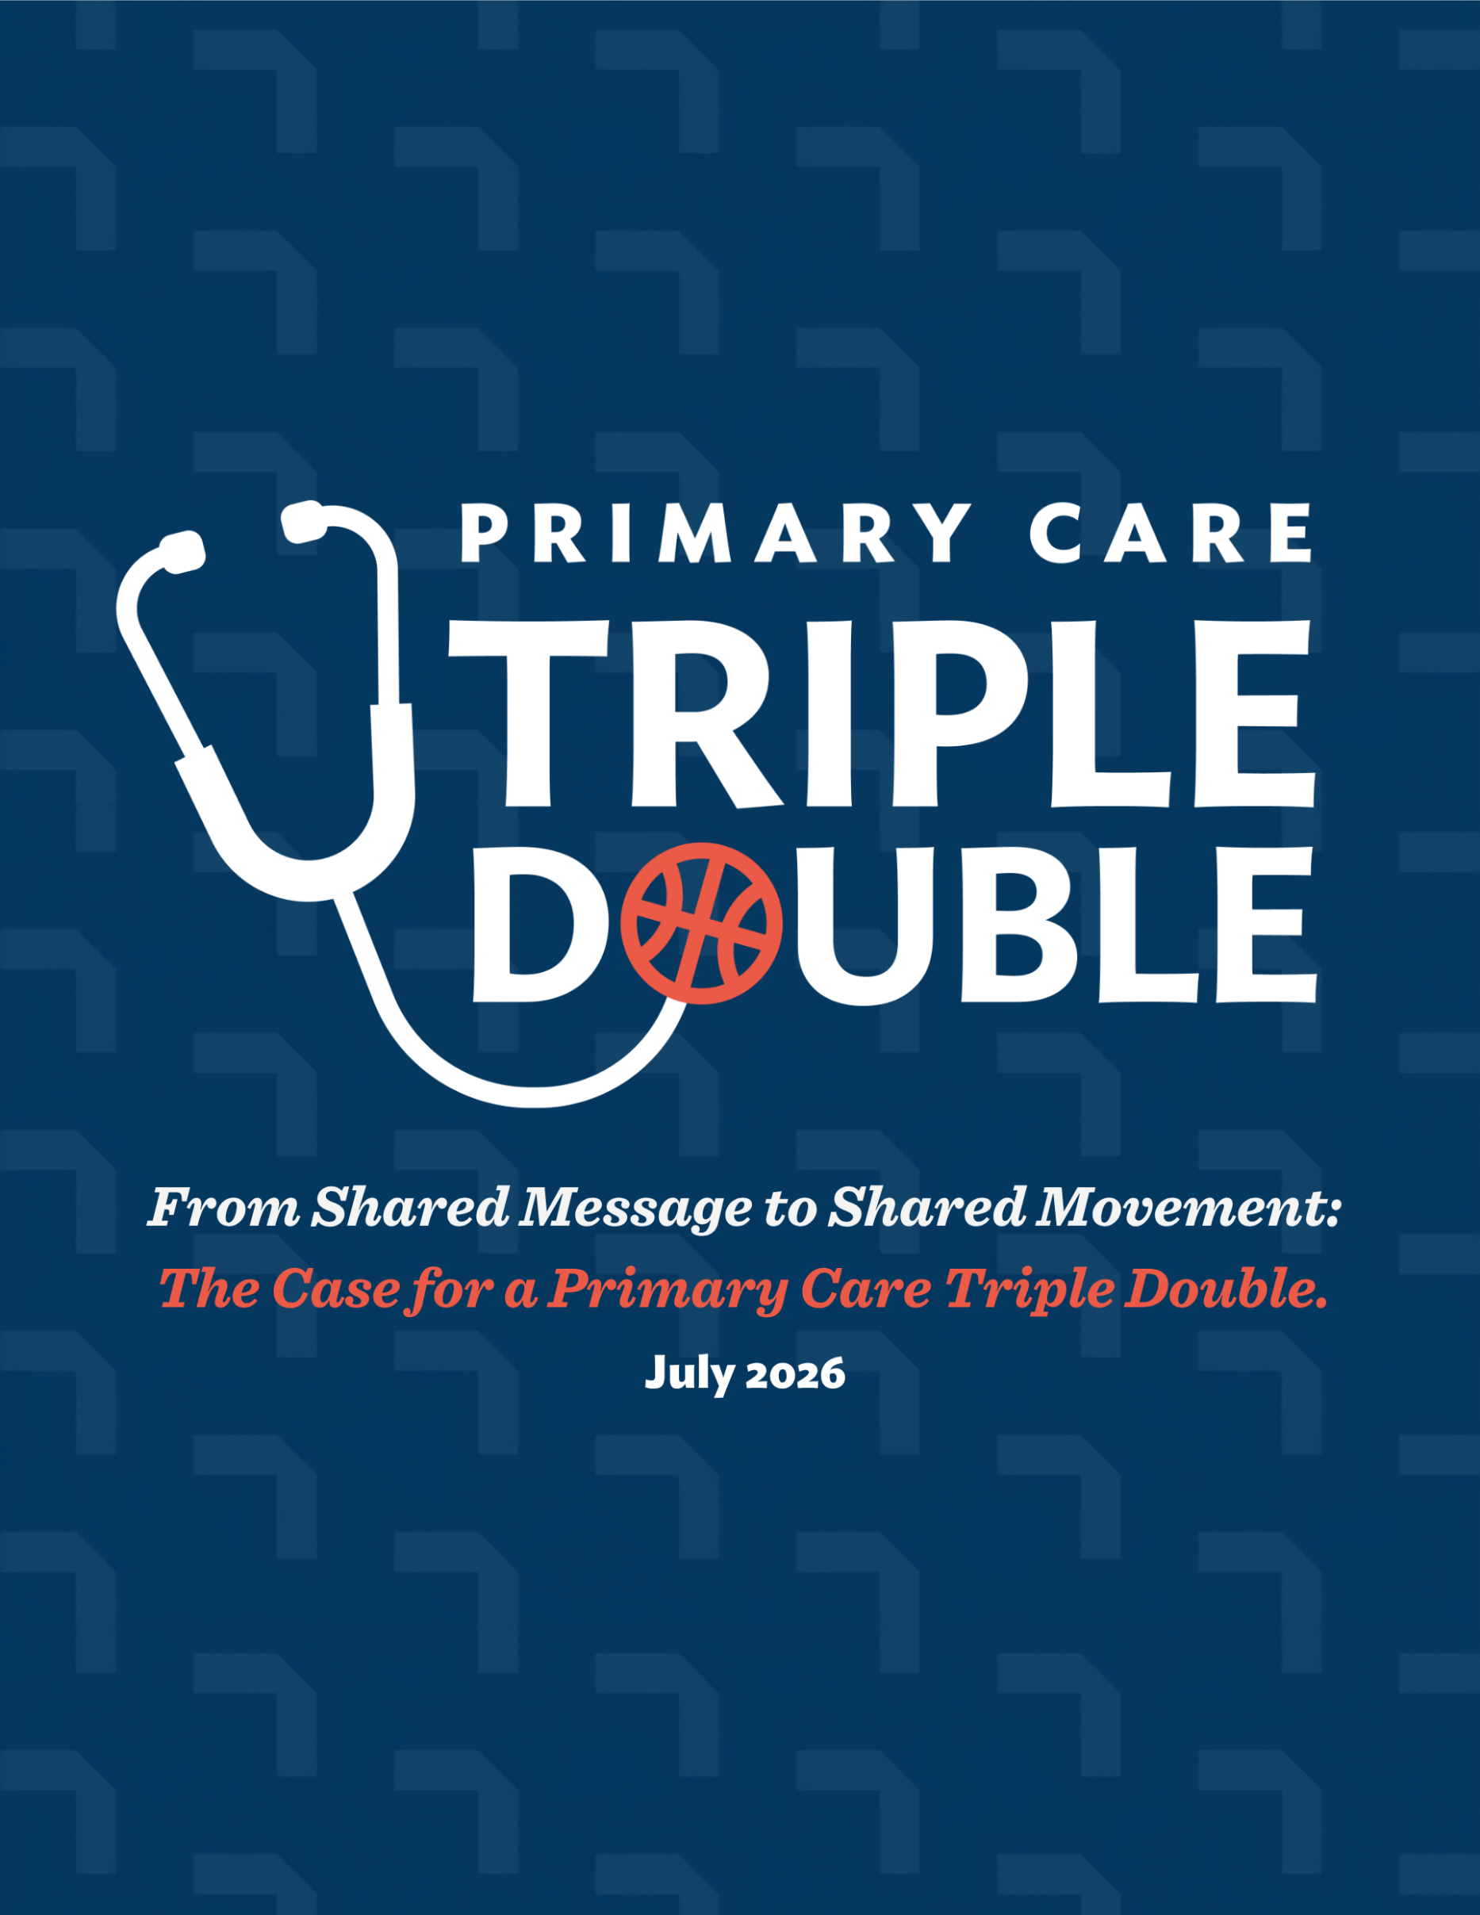
Primary Care for America. From Shared Message to Shared Movement:
The Case for a Primary Care Triple Double. July 2026

It took a crisis to bring us together. Community health centers governed by their patients across the nation's most underserved communities; family physicians and clinicians taking care of patients across every zip code in America; researchers and innovators translating evidence into health system transformation; and policy experts with decades of national and state-level policy experience spanning payment reform, access to care, and workforce. We are united under a shared conviction that the primary care crisis in the United States has reached an urgent tipping point – and calls for bold, unified action.
We are calling for a Primary Care Triple Double: doubling primary care investment, doubling the reach of primary care, beginning with community health centers, and doubling the share of new clinicians training and practicing in primary care. Launched jointly by American Academy of Family Physicians (AAFP) and the National Association of Community Health Centers (NACHC) and coordinated through Primary Care for America, with strategic and thought leadership from Ariadne Labs and PolicyPRN Consulting, the Triple Double Campaign is an effort to build state and national primary care champions around shared messaging, clear evidence, and common goals to expand access to primary care and improve the nation’s health.
The Evidence Has Never Been Stronger — and Neither Has the Crisis
Primary care is the only part of the health care system in which investment routinely produces better health outcomes. That is not a rhetorical claim. It is one of the central findings of the National Academies of Sciences, Engineering, and Medicine's landmark 2021 consensus report, Implementing High-Quality Primary Care: Rebuilding the Foundation of Health Care. The evidence is extensive and consistent: adults with a usual source of primary care are significantly more likely to receive cardiovascular risk factor screening and cancer screenings, and significantly less likely to experience avoidable emergency department visits and hospitalizations. For every 10 additional primary care physicians per 100,000 population, life expectancy increases at the county level by more than 50 days. And recent research finds that for adults with chronic disease who had a usual source of primary care, health care costs were nearly 54% lower.
Access to primary care is important to patients, especially those who are medically under-resourced. Community Health Centers (CHCs) are the strongest primary care infrastructure in our health care system— delivering wider access for underserved populations, equal or better quality in managing chronic and preventive conditions, and better value for patients with the most complex needs. CHCs serve 54 million patients – or 1 in 7 Americans - across over 17,000 sites, reaching 1.5 million people experiencing homelessness, 400,000 veterans, and 9.9 million rural residents (1 in 3 rural residents). These are not patients who can afford to lose access to care.
Indeed, trusted primary care is critical to patients everywhere. National Medicare data show that patients who see the same primary care physician consistently have lower total health care costs and fewer hospitalizations than those who don't, regardless of practice type or setting. Continuity with a trusted primary care clinician is one of the most consistent predictors of better outcomes in American health care.
Without primary care, minor health issues can spiral into life-threatening chronic diseases. Over 60% of U.S. adults have at least one chronic disease, and over 40% have two or more. Yet the system is weakening precisely when it is needed most. According to the 2026 Primary Care Scorecard, nearly 30% of U.S. adults still lack a usual source of care. The number of primary care physicians per 100,000 population has also been declining, falling from 68.4 in 2012 to about 67 in recent years. The Health Resources and Services Administration (HRSA) projects a primary care physician shortage of more than 70,000 by 2038 — a gap that even a growing supply of nurse practitioners (NPs) and physician associates (PAs) is not expected to fully close in areas facing the greatest need.
Chronic underinvestment is contributing to this crisis in health and access.. Primary care accounts for 35% of all health care visits but captures only 5% of expenditures — a distribution that leaves primary care practices challenged to support the comprehensive, team-based, relationship-centered entities that the evidence shows produce good outcomes. Research has demonstrated that advanced primary care practices cannot be financially sustained on a fee-for-service chassis: the payment model rewards visit volume, not the longitudinal, coordinated, whole-person care that defines effective primary care. A subsequent analysis found that 63% of a practice's revenue needed to be delivered through prospective capitated payment to meaningfully support team-based care and achieve a net surplus for practices to keep the doors open. Most practices are far from that threshold.
Unfortunately, current graduate medical education (GME) funding policy compounds the workforce shortage. Medicare spends billions of dollars annually on GME, yet these funds carry no meaningful requirement to produce primary care physicians; only 1 in 5 physicians who complete GME enter primary care practice. Analyses show an inverse correlation between GME payments per capita by state and the proportion of new physicians entering primary care: states receiving the most GME funding tend to produce the fewest primary care physicians. Accordingly, we are subsidizing residency training that isn't producing the primary care physicians the country needs. And while NPs and PAs are critical to addressing the primary care workforce gap, they, too, are subject to the same economic pressures pulling clinicians toward higher-paying specialties, leaving just 29% of NPs and 24% of PAs actively working in primary care. We need to expand training opportunities across the care team and make primary care a more viable career choice.
Why a Triple Double — and Why Now
In basketball, a triple double — achieving double digits in at least three of five statistical categories – is often game-changing: the team with a player who achieves a triple double will usually win their game. For a player, a triple double requires laser-focused execution across multiple dimensions of play, exactly the kind of disciplined, multi-front effort that primary care transformation requires.
The Primary Care Triple Double Campaign sets three interconnected, bold goals:
Goal 1: Double primary care investment — from 5% to 10% of total health care spending.
In 2023, the U.S. spent $4.9 trillion on health care, with more than 75% of costs related to preventable chronic conditions which remain the leading cause of death among adults. Primary care is the only health care component where increased supply is associated with better community health, yet only 4.7% of health care spending in the U.S. goes towards primary care. The target of 10% reflects not only the level of investment, but also its form and flow. Moving away from fee-for-service toward prospective, capitated payment, and ensuring that dollars actually reach primary care teams in the communities they serve, is as important as the aggregate percentage. Nearly 20 states have already enacted or are developing primary care spending targets ranging from 10% to 15% of total health care expenditures. States like Rhode Island demonstrated that doubling primary care's share of spending within five years is achievable while keeping overall costs budget neutral. The policy tools exist. The question is political will.
Goal 2: Double the reach of primary care, starting with CHCs — from 10% to 20% of Americans served annually.
We start with CHCs because they are already the most scalable infrastructure serving the medically underserved in 17,000 communities nationwide. Required by law to treat all patients regardless of insurance status or ability to pay, they offer care on a sliding-fee scale for patients who report being priced out of primary care elsewhere. Doubling their reach through sustained investment in CHC capacity, infrastructure, and workforce would extend care to millions more of the nearly 30% of U.S. adults and growing share of children who lack a usual source of primary care. But CHC growth alone will not close the U.S. access gap. Reaching every American will require the workforce and payment reforms described in Goals one and three.

Goal 3: Double the share of new clinicians entering primary care — from 20% to 40%.
Reaching 40% will require a systemic reorientation of GME funding toward primary care training in community-based settings through expansion of the Teaching Health Center GME program, the National Health Service Corps, and other reforms that invest in primary care clinicians and their care teams. It will require aligning financial incentives so that the growing income gap between primary care and specialty practice no longer works against a student's choice to pursue primary care. And it will require training clinicians in the communities where people live and work, not exclusively in academic medical centers.
From Evidence to Movement: How the Campaign Works
The evidence for primary care investment has been compelling for decades. The problem has never been a lack of data, but rather, the absence of a unified, durable narrative capable of translating evidence into action and unifying all primary care's stakeholders.
The Triple Double Campaign was designed to fill that gap. Its function is precisely defined: a unified messaging campaign with a curated policy menu for each of the three goals, built to motivate state and national collective action, adaptable based on the individual context of each organization and state. It is a platform for amplification and alignment, designed to be flexible, inclusive, and collaborative.
The campaign operates through three complementary tracks, each designed to reinforce the others.
- The first is a unified messaging campaign — providing shared language, talking points, media strategy, and curated policy menus for each Triple Double goal, convened at the state and national levels and anchored within Primary Care for America, with leadership drawn from across health sectors and stakeholder communities.
- The second is the Triple Double Learning Lab — a tiered grassroots advocacy education curriculum, cohort-based and designed to educate and train primary care stakeholders from CHCs, Primary Care Associations, and other interested organizations, led by NACHC and built on the foundation of their respected Advocacy Leadership Program.
- The third is State Collaboratives — providing grants and technical assistance to activate state-level coalitions that bring together a broad set of stakeholders, including AAFP chapter leaders and Primary Care Associations – together with disease advocacy organizations, patient and clinician advocacy groups, and other primary care champions - to drive progress toward Triple Double goals, generate proof points, and build the cross-sector momentum that sustains a movement.
The theory of change is a reinforcing cycle: shared messaging catalyzes alignment among organizations that might otherwise work in parallel; enabling tools lower the barriers for state-level action; a unified narrative amplifies collective voice for policymakers, funders, and new partners; and state and national proof points generate the momentum that attracts more partners and produces policy change. Decades of state-level experience across payment reform, access to care, and workforce reform show that national campaigns succeed when they are organized and tailored around state needs and priorities.
A central strategy of the Triple Double is to connect state chapters of the AAFP with state Primary Care Associations, together with existing primary care collaborative efforts, like those led by the Primary Care Investment Network (PCIN), the Milbank Memorial Fund, and the National Academy for State Health Policy. Finally, tracking progress and sharing insights with partners at NACHC, AAFP, and PCfA events and convenings will help to disseminate learnings, celebrate success, and motivate other primary care champions to join in our shared primary care movement.
Lessons from successful social movements are instructive here. The campaigns that have changed entrenched policy have turned grassroots energy into organized power; connected state-based strategies under a unifying theme; changed hearts through lived experience alongside policy through data; and cultivated both strong central leadership and strong local leaders. The Triple Double Campaign is designed with all of those lessons in mind.
Triple Double Campaign: Centered on the Needs of Patients
Everyone deserves access to primary care. In 2025 polling, more than eight in ten Americans (83%) said having a regular primary care clinician is a high priority, and over half (52%) call it a top priority, yet cost and access are the most cited barriers to getting care, across every demographic group. When primary care is under resourced, practices must see more patients in less time to stay financially viable, leaving less room for the questions, trust-building, and complex-need management that primary care is supposed to provide. Nationally, the top reasons patients report dissatisfaction with primary care are a rushed appointment (26%), a provider who didn't spend enough time with them (23%), and long wait times (20%) — all downstream symptoms of a payment system that doesn't fund the model patients say they want.
Chronic disease advocacy organizations are also increasingly focused on primary care. The American Heart Association explicitly built its 2025 hypertension guideline around primary care, calling for multidisciplinary, team-based screening and management to control hypertension, which is the single most modifiable risk factor for heart disease, stroke, and kidney disease.
The American Cancer Society's national screening data demonstrate that having a usual source of care is one of the strongest predictors of getting recommended breast, cervical, and colorectal cancer screening; those without insurance or a trusted clinician are screened and diagnosed with cancer at later, less treatable stages.
The American Diabetes Association created a standing Primary Care Advisory Group and a dedicated abridged version of its annual Standards of Care specifically for primary care clinicians, a recognition that diabetes prevention and management is fundamentally a primary care function, not a specialty one. Three of the costliest, deadliest chronic disease categories in America point to the same solution: access to primary care.
A Call to Action
The evidence is not in question: primary care saves lives, saves money, and is the part of the health system Americans trust most — yet it receives just 5% of health care spending, leaves nearly a third of adults without a usual source of care, and trains and retains too few of the clinicians it needs. The Triple Double creates the shared messaging and movement to address it: doubling investment, doubling the reach of primary care starting with CHCs, and doubling the share of clinicians who choose this work. The policy tools exist. The evidence is overwhelming. The champions are ready. What has been missing is a unified movement at the state and national level to make it happen — and that’s the movement we are seeking to create.
We need every payer, policymaker, health system, clinician organization, patient advocate, and community leader who believes in what primary care can do.
Here's how to join us:
- Visit [primarycareforamerica.org/goals] to learn more about the campaign and the evidence behind it
- Sign up as a supporter to receive updates and add your voice to the movement
- Consider joining the Partners Council — our coalition of organizations driving this work at the state and national level
Primary Care Triple Double Campaign: Double the investment. Double the reach. Double the workforce. Help us move from a shared message to a shared movement, today.
Suggested citation:
Primary Care for America. From Shared Message to Shared Movement: The Case for a Primary Care Triple Double. July 2026

National Academies of Sciences, Engineering, and Medicine. Implementing High-Quality Primary Care: Rebuilding the Foundation of Health Care. Washington, DC: The National Academies Press; 2021.
Jabbarpour Y, Jetty A, Byun H, Siddiqi A, Petterson S, Park J. Investing in Primary Care: The Missing Strategy in America's Fight Against Chronic Disease. New York, NY: Milbank Memorial Fund; 2025.
Basu S, Berkowitz SA, Phillips RL, Bitton A, Landon BE, Phillips RS. Association of primary care physician supply with population mortality in the United States, 2005–2015. JAMA Internal Medicine. 2019;179(4):506–514
Jabbarpour Y, Jetty A, Byun H, Siddiqi A, Petterson S, Park J. Investing in Primary Care: The Missing Strategy in America's Fight Against Chronic Disease. New York, NY: Milbank Memorial Fund; 2025.
KFF. Quality of Care in Community Health Centers and Factors Associated with Performance. San Francisco, CA: KFF; 2025
KFF, "Community Health Center Patients, Financing, and Services" (updated Feb 11, 2026, based on 2024 UDS); NACHC, "2024 UDS Early Takeaways" and "America's Health Centers: By the Numbers."
Bazemore A, Petterson S, Peterson LE, Bruno R, Chung Y, Phillips RL. Higher Primary Care Physician Continuity Is Associated With Lower Costs and Hospitalizations. Annals of Family Medicine. 2018;16(6):492-497
Benavidez GA, Zahnd WE, Hung P, Eberth JM. Chronic Disease Prevalence in the U.S.: Sociodemographic and Geographic Variations by Zip Code Tabulation Area. Prev Chronic Dis 2024;21:230267. DOI: http://dx.doi.org/10.5888/pcd21.230267.
National Academies of Sciences, Engineering, and Medicine. Implementing High-Quality Primary Care: Rebuilding the Foundation of Health Care. Washington, DC: The National Academies Press; 2021.
Jabbarpour Y, Jetty A, Byun H, Siddiqi A, Park J, Koller CF. 2026 Primary Care Scorecard. New York, NY: Milbank Memorial Fund and The Physicians Foundation; 2026.
Jabbarpour Y, Jetty A, Byun H, Siddiqi A, Park J, Koller CF. 2026 Primary Care Scorecard. New York, NY: Milbank Memorial Fund and The Physicians Foundation; 2026.
National Center for Health Workforce Analysis. Physician Workforce: Projections, 2023–2038. Rockville, MD: Health Resources and Services Administration; 2025.
McCauley L, et al. Chapter 3: Primary Care in the United States: A Brief History and Current Trends. In: McCauley L, et al., eds. Implementing High-Quality Primary Care: Rebuilding the Foundation of Health Care. Washington, DC: The National Academies Press; 2021:71-92.
Basu S, Phillips RS, Song Z, Bitton A, Landon BE. High Levels of Capitation Payments Needed to Shift Primary Care Toward Proactive Team and Nonvisit Care. Health Affairs. 2017;36(9):1599-1605.
Basu S, Phillips RS, Bitton A, Song Z, Landon BE. High Levels of Capitation Payments Needed to Shift Primary Care Toward Proactive Team and Nonvisit Care. Health Affairs. 2017;36(9):1599-1605.
Fenster TL, Park J, Huffstetler AN, Topmiller M. Graduate Medical Education Funding Does Not Flow to Primary Care Physician Production. American Family Physician. 2026;113(4):321-322.
Jabbarpour Y, Jetty A, Byun H, Siddiqi A, Park J, Koller CF. 2026 Primary Care Scorecard. New York, NY: Milbank Memorial Fund and The Physicians Foundation; 2026.
Guo A, Sohn D. Analyzing the True Value of the Triple Double in the Modern NBA. Los Angeles, CA: Bruin Sports Analytics; 2022.
Bitton A. Primary Care Needs a Triple Double: A Call to Action. New York, NY: Milbank Memorial Fund; 2025.
Munira Z. Gunja, Evan D. Gumas, and Reginald D. Williams II, U.S. Health Care from a Global Perspective, 2022: Accelerating Spending, Worsening Outcomes (Commonwealth Fund, Jan. 2023). https://doi.org/10.26099/8ejy-yc74
Jabbarpour Y, Jetty A, Byun H, Siddiqi A, Petterson S, Park J. The Health of US Primary Care: 2024 Scorecard Report — No One Can See You Now. The Milbank Memorial Fund and The Physicians Foundation. February 28, 2024.
Milbank Memorial Fund. A Framework for Evaluating Primary Care Investment. New York, NY: Milbank Memorial Fund; 2026.
Milbank Memorial Fund. Five States Leading Efforts to Increase Primary Care Spending. New York, NY: Milbank Memorial Fund; 2025
Bitton A. Primary Care Needs a Triple Double: A Call to Action. New York, NY: Milbank Memorial Fund; 2025.
National Association of Community Health Centers. Closing the Primary Care Gap: How Community Health Centers Can Address the Nation's Primary Care Crisis. Bethesda, MD: NACHC; 2023.
Jabbarpour Y, Jetty A, Byun H, Siddiqi A, Park J, Koller CF. 2026 Primary Care Scorecard. New York, NY: Milbank Memorial Fund and The Physicians Foundation; 2026.
National Association of Community Health Centers. Community Health Centers: Making America Healthier One Community At A Time. Bethesda, MD: NACHC; June 2026.
National Academies of Sciences, Engineering, and Medicine. Implementing High-Quality Primary Care: Rebuilding the Foundation of Health Care. Washington, DC: The National Academies Press; 2021.
Crutchfield LR, Novelli B. How Change Happens: Why Some Social Movements Succeed While Others Don't. Hoboken, NJ: Wiley; 2018.
National Partnership for Women & Families, United States of Care. Underinvestment in Primary Care Harms Patients. Washington, DC: National Partnership for Women & Families; May 2026.
National Partnership for Women & Families, United States of Care. Underinvestment in Primary Care Harms Patients. Washington, DC: National Partnership for Women & Families; May 2026.
American College of Cardiology/American Heart Association Joint Committee on Clinical Practice Guidelines. 2025 AHA/ACC/AANP/AAPA/ABC/ACCP/ACPM/AGS/AMA/ASPC/NMA/PCNA/SGIM Guideline for the Prevention, Detection, Evaluation, and Management of High Blood Pressure in Adults. Hypertension. 2025.
American Cancer Society. Cancer Prevention & Early Detection Facts & Figures 2025-2026. Atlanta, GA: American Cancer Society; 2025.
American Diabetes Association Professional Practice Committee for Diabetes. Standards of Care in Diabetes—2026. Diabetes Care. 2026;49(Suppl 1).

