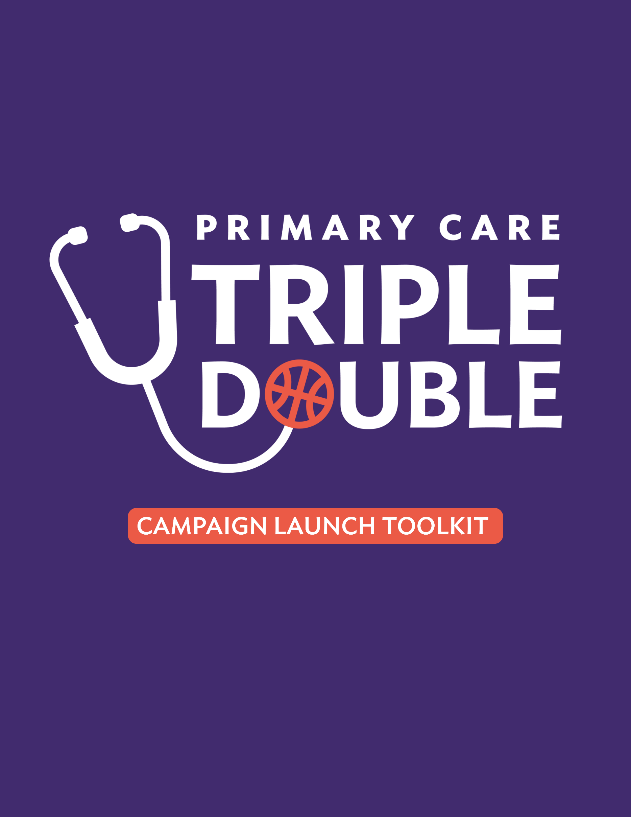
About this Toolkit
Thank you for your participation in the Primary Care Triple Double: Investment. Access. Workforce. Doubled. campaign. Your support will help build awareness, increase engagement and drive momentum around a clear, achievable path to strengthen primary care.

The Campaign Launch Toolkit is designed to introduce policymakers, health care leaders, community partners, and advocacy networks to the Triple Double campaign and its vision for strengthening primary care. It provides foundational messaging, educational materials, and promotional assets to help audiences understand the challenges facing primary care and the opportunities created by focusing on three connected goals.

The Triple Double campaign is focused on three connected goals: doubling investment in primary care, doubling the reach of primary care and doubling the next generation primary care workforce. Together, these goals support a stronger health system where more people can access timely, affordable and coordinated care in their communities.

To help amplify this effort, please use the digital and promotional assets in this document. These materials are designed to help you share unified campaign messages, engage policymakers and state leaders, and encourage influential voices to get involved.

This toolkit is the first in a series of campaign resources and focuses on building understanding and awareness of the Triple Double and its goals. Future toolkits will provide additional resources to support advocacy, stakeholder engagement, communications, and grassroots activation efforts.

Table of Contents
Triple Double Factsheet 3
Talking Points for Policymakers 5
Frequently Asked Questions 7
Press Release Template 9
Social Media 11

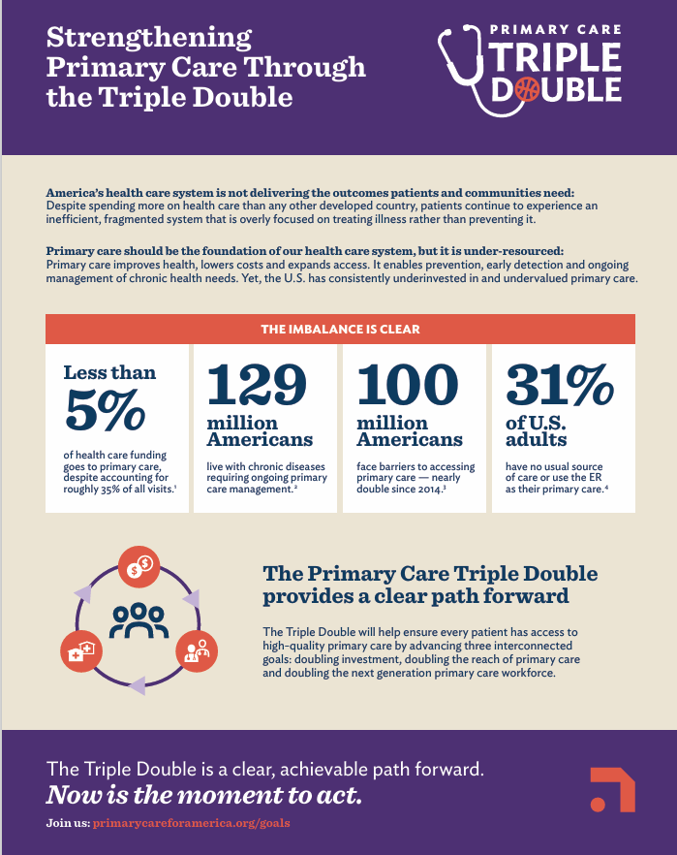
Triple Double Factsheet

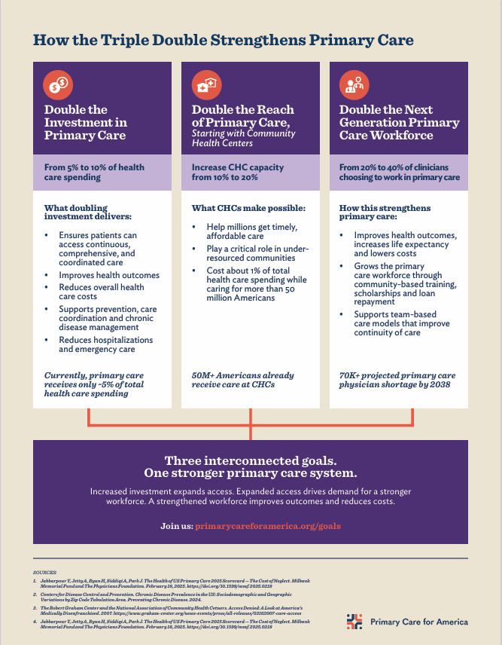

Talking Points for Policymakers
Use these talking points in meetings, events, hearings and other conversations with policymakers or state leaders. You are encouraged to tailor them with state-specific data, local examples and policy priorities.
- America’s health care system is not delivering the outcomes patients and communities need. The U.S. spends more on health care than any other developed country, yet continues to see worse outcomes. Our system is inefficient, fragmented and too focused on treating illness instead of preventing it.
- Primary care should be the foundation of a strong health system, but it is under-resourced. Primary care improves health, lowers costs and expands access, yet the U.S. has consistently underinvested in and undervalued it.
- In [STATE], we see this challenge show up through [INSERT STATE-SPECIFIC CHALLENGE]. Patients and communities are facing barriers such as [INSERT EXAMPLES: long wait times [over X# minutes], workforce shortages [of X# providers], rural access gaps, X% community health center capacity, high emergency department use], and we need support to strengthen primary care where people live.
- The Primary Care Triple Double is an efficient strategy to strengthen the health system. It advances three connected goals: double investment in primary care, double the reach of primary care and double the next generation primary care workforce.
- These three pillars work together to drive system-wide impact: where increased investment expands access to care, expanded access drives demand for a stronger workforce, and a strengthened workforce improves outcomes and reduces costs.

- The Triple Double’s shared goals create momentum that fragmented efforts cannot achieve alone, allowing us to still focus on what is most relevant to our state, while connecting our work to a broader movement.
- Our specific focus in [STATE] is…
  - Doubling investment in primary care from 5% to 10% of health care spending would help deliver more coordinated care that reduces costs and improves outcomes.
    - Primary care receives less than 5% of overall health care funding. That underinvestment drives higher costs downstream, including avoidable hospitalizations and emergency care.
    - Greater investment supports prevention, care coordination and chronic disease management — keeping patients healthy long-term, not just treating illness.
    - [INSERT POLICY NEED/ STATE-SPECIFIC STRATEGY ASK TO SUPPORT INVESTMENT IN PRIMARY CARE]
  - Doubling the reach of primary care, starting with increasing community health centers capacity from 10% to 20%, would help more people receive timely, affordable care.
    - More than 50 million Americans already receive care at community health centers–demonstrating a proven, scalable model.
    - In [STATE/COMMUNITY], this could help address [INSERT LOCAL ACCESS NEED] and reduce strain on the broader health system.
    - [INSERT POLICY NEED/ STATE-SPECIFIC STRATEGY ASK TO SUPPORT ACCESS]
  - Doubling the number of clinicians choosing to practice in primary care from 20% to 40% of the workforce would help ensure every community has access to the care it needs.
    - Based on the current trajectory, by 2038 America is expected to face a shortage of more than 70,000 primary care physicians.
    - A stronger workforce improves continuity of care and patient outcomes: every 10 additional primary care physicians per 100,000 population increases life expectancy by 51.5 days.
    - [INSERT POLICY NEED: community-based training, scholarships, loan repayment, team-based care models or rural workforce support].
- The Triple Double is a clear, achievable path forward — now is the moment to act. We can work together to advance strategies that reflect our state and local priorities to build momentum and scale what works.
- If we want better health outcomes, lower costs and a stable workforce, we must invest in primary care the way we say we value it.

Frequently Asked Questions
Use these FAQs to help answer common questions from policymakers, state leaders, partner organizations and other influential stakeholders.
- What is Triple Double? The Primary Care Triple Double: Investment. Access. Workforce. Doubled. is a practical strategy to strengthen the health system by advancing three connected goals: doubling investment in primary care, doubling access to primary care and doubling the next generation primary care workforce.
- Why is the Triple Double needed? America’s health care system is not delivering the health outcomes patients and communities need. Despite spending more on health care than any other developed country, the U.S. continues to see worse outcomes. The system is inefficient, fragmented and too focused on treating illness rather than preventing it.
Primary care is one of the most practical ways to shift the system toward prevention, coordination and better long-term outcomes, but it remains under-resourced. The Triple Double addresses this by advancing three connected goals: increased investment expands access to care, expanded access creates demand for a stronger workforce, and a strengthened workforce improves outcomes and reduces costs.
- Why focus on primary care? Primary care is the foundation of a strong health system. It improves health, lowers costs and expands access, yet the U.S. has consistently underinvested in and undervalued it. Primary care serves as the first point of contact for patients and supports prevention, early detection and ongoing management of chronic health needs.
- Why should policymakers invest in primary care? Primary care accounts for over half of outpatient patient visits but receives less than 5% of health care spending. This imbalance limits access, strains the workforce and drives higher downstream costs. Doubling investment in primary care from 5% to 10% of health care spending would provide the resources needed to deliver comprehensive, coordinated care.
- Why should policymakers expand access to primary care? One hundred million Americans lack a regular doctor or care team, leading to delayed care and worse outcomes. Expanding access to primary care, starting with increasing community health center capacity from 10% to 20%, would help more people receive timely, affordable care. Community health centers already serve more than 50 million Americans, demonstrating a proven model for bringing comprehensive, community-based care to more people.
- Why should policymakers support the primary care workforce? A limited share of clinicians currently choose to train and practice in primary care, contributing to shortages and limiting access to care. By 2038, America is expected to face a shortage of more than 70,000 primary care physicians. Doubling the number of clinicians choosing to practice in primary care from 20% to 40% of the workforce would help ensure every community has access to timely, continuous care.
- Who is involved in the Triple Double? The Triple Double Campaign brings together the National Association of Community Health Centers (NACHC) and the American Academy of Family Physicians (AAFP) – founding partners of Primary Care for America — alongside a growing movement of organizations, thought leaders, [OPTIONAL: INSERT ORGANIZATION THAT MIGHT BE IMPRESSIVE OR RECOGNIZED BY POLICYMAKERS], and state leaders working to strengthen primary care at every level.
By uniting the broader primary care community, the Triple Double builds shared support for stronger primary care investment, expanded access and a workforce prepared to meet the needs of every community.
- What are you asking policymakers to do? Policymakers can make primary care a greater priority in health policy and funding decisions. That includes supporting strategies that [INSERT POLICY NEED BASED ON STATE GOALS/PRIORITIES]. The goal is to build momentum at the state and local levels and scale what works.
- Do states need to support all three Triple Double goals? No. The Triple Double’s shared goals create momentum that fragmented efforts cannot achieve alone. By allowing states to focus on the goal that best reflects their state’s needs, policy priorities or audience, it connects our effort to a broader movement to strengthen primary care.
- Why should I care about the other goals if my state or organization is focused on one? The Triple Double’s three goals work together to advance primary care transformation: Increased investment helps expand access to care, expanded access creates demand for a stronger workforce, and a strengthened workforce improves outcomes and reduces costs.
- How do I choose which Triple Double goal to support? States should focus on the primary care challenge that is most urgent or actionable in your state or community. If the biggest issue is underfunding or payment, lead with investment. If patients are struggling to find timely, affordable care, lead with access. If shortages or training gaps are limiting care, lead with workforce. The goal is to connect our state’s needs to the part of the Triple Double creating the clearest path to building and sustaining a primary care system our communities deserve.

Press Release Template
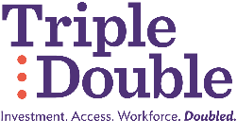
[INSERT ORGANIZATION LOGO]

FOR IMMEDIATE RELEASE
Media Contact:
[NAME]
[ORGANIZATION]
[EMAIL]
[PHONE]
[INSERT ORGANIZATION NAME] Joins Primary Care Triple Double Campaign to Strengthen Investment, Access and Workforce
[CITY, STATE] — [DATE] — Today, [INSERT ORGANIZATION NAME] announced its participation in the Triple Double: Investment. Access. Workforce. Doubled. campaign, a national effort to strengthen the U.S. health system by advancing three connected goals: doubling investment in primary care, doubling access to primary care and doubling the next generation primary care workforce. Primary care improves health, lowers costs and expands access, yet the U.S. has consistently underinvested in and undervalued it.
“[INSERT ORGANIZATION NAME] is joining the Primary Care Triple Double because [INSERT ORGANIZATION-SPECIFIC GOAL, FOCUS, AND REASON FOR JOINING/SUPPORTING],” said [INSERT NAME], [INSERT TITLE] at [INSERT ORGANIZATION NAME]. “Primary care is the foundation of a strong health system, and this campaign gives policymakers, health care leaders and advocates a clear path to support better access, stronger outcomes and more sustainable care.”
The Triple Double campaign advances three connected goals:
- Double the Investment in Primary Care from 5% to 10% of health care spending to provide the resources needed for comprehensive, coordinated care that improves outcomes and reduces costs. Greater investment supports prevention, care coordination and chronic disease management – helping clinicians focus on keeping patients healthy, not just treating illness.
- Double the Reach of Primary Care, starting with expanded capacity in community health centers, so more people can receive timely, affordable care in their communities. More than 50 million Americans already receive care at community health centers, demonstrating a proven model for expanding access and reducing strain on the broader health system.
- Double the Next Generation Primary Care Workforce from 20% to 40% of clinicians choosing to work in primary care helps ensure every community has access to the care it needs. Strengthening the primary care workforce pipeline supports continuity of care, improves patient outcomes and helps address projected shortages.
These three pillars work together to drive system-wide impact: where increased investment expands access to care, expanded access drives demand for a stronger workforce, and a strengthened workforce improves outcomes and reduces costs. Primary care is widely seen as the most practical lever for system reform, across the political spectrum, however current policy choices have contributed to the strain on primary care. Advancing these three strategies in tandem creates a clear path to better outcomes, improved access and a more sustainable health system.
Through this campaign, [INSERT ORGANIZATION NAME] will build on its ongoing work to [INSERT ORGANIZATION PRIORITY] and help advance policies that strengthen primary care across [INSERT STATE/REGION/NATIONWIDE]. [INSERT ORGANIZATION NAME] will support the effort by [INSERT ACTIVATION], helping build momentum for stronger investment, expanded access and a more robust primary care workforce.
To learn more, visit https://www.primarycareforamerica.org/goals/
About [INSERT ORGANIZATION NAME]
[INSERT ORGANIZATION BOILERPLATE]
About the Triple Double
The Triple Double: Investment. Access. Workforce. Doubled. is a campaign focused on strengthening primary care through three connected goals: doubling investment in primary care, doubling access to primary care and doubling the next generation primary care workforce. The campaign brings together the National Association of Community Health Centers (NACHC) and the American Academy of Family Physicians (AAFP) — founding partners of Primary Care for America — alongside a growing movement of organizations, thought leaders including Ariadne Labs, and state leaders working to strengthen primary care at every level. By uniting the broader primary care community around shared goals, the Triple Double campaign is building momentum for stronger primary care investment, expanded access and a workforce prepared to meet the needs of every community.

Social Media
We have curated a few graphic options for you to choose from, which you can download here.
Of the graphics to choose from, there are:
- General “What is Triple Double?” graphic
  - Introduces the campaign and the three core focus areas: investment, access and workforce.
- Primary care investment and state/local action carousel
  - Highlights why primary care needs greater support and how Triple Double goals can be tailored at the state and local levels.
- “Join Triple Double and Drive Action” graphic
  - Encourages policymakers, health care leaders, advocates and partner organizations to get involved.

Pro Tip: When sharing your preferred graphic, upload the graphic file before you paste your copy with the campaign link.
Below, you will find social media copy options to post on your organization’s platforms. These sample posts are designed to pair with any of the Triple Double graphics included in this toolkit.
Please keep in mind some sample text includes placeholders for you to add your organization’s name and the campaign link. We encourage you to tailor the copy to reflect why your organization is supporting the Triple Double: Investment. Access. Workforce. Doubled. campaign.
We would love to engage with you, so please tag Primary Care for America on social media — our handles are included below.
- LinkedIn
  - To tag Primary Care for America on LinkedIn, type the “@” and type out the full name.
- X (Twitter)
  - To tag Primary Care for America on X, type the “@” and type “PC4America”.
Social Media Copy
For use on LinkedIn
Option 1
At [INSERT ORGANIZATION NAME], we are proud to join the Triple Double: Investment. Access. Workforce. Doubled.
Primary care should be the foundation of a strong health system, but it remains under-resourced.
Through Triple Double, we are supporting a clear path to strengthen primary care by increasing investment, expanding access and growing the next generation workforce.
Join us in supporting stronger primary care: https://www.primarycareforamerica.org/goals/
Option 2
[INSERT ORGANIZATION NAME] is joining the Triple Double because strengthening primary care is essential to improving health, lowering costs and expanding access.
The campaign is focused on three connected goals: double investment in primary care, double access to primary care and double the next generation primary care workforce.
Now is the moment to act. Learn more and be part of the effort: https://www.primarycareforamerica.org/goals/
Option 3
Primary care improves health, lowers costs and expands access — yet it remains under-resourced.
That is why [INSERT ORGANIZATION NAME] is supporting the Triple Double: Investment. Access. Workforce. Doubled. Together, policymakers, health care leaders and advocates can build momentum for stronger primary care in communities across the country.
Be part of the effort: https://www.primarycareforamerica.org/goals/
For use on X
To tag Primary Care for America on X, type “@” and type “PC4America.”
Option 1
At [INSERT ORGANIZATION NAME], we are proud to join the Triple Double: Investment. Access. Workforce. Doubled.
Together, we can help strengthen primary care by increasing investment, expanding access and growing the next generation workforce.
Learn more: https://www.primarycareforamerica.org/goals/
Option 2
Primary care should be the foundation of a strong health system. [INSERT ORGANIZATION NAME] is joining the Primary Care Triple Double to help build momentum for stronger investment, expanded access and a growing workforce.
Join us: https://www.primarycareforamerica.org/goals/
Option 3
The Triple Double is a clear path to strengthen primary care: double investment, double access and double the next generation workforce.
[INSERT ORGANIZATION NAME] is proud to be part of this effort.
Learn more: https://www.primarycareforamerica.org/goals/

